Run Skype for Business Server Topology Builder

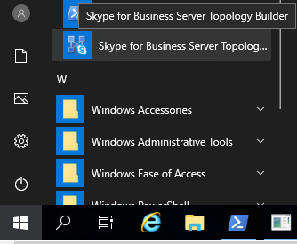

Create a New Topology

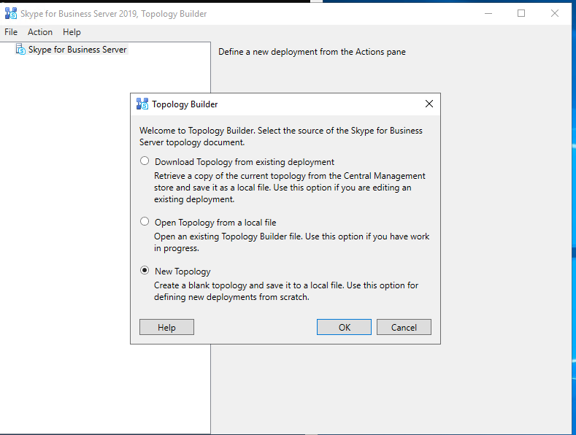

Name the file that store the Topology

You do not need to preserve or capture this file, it is merely a record holder for the Topology

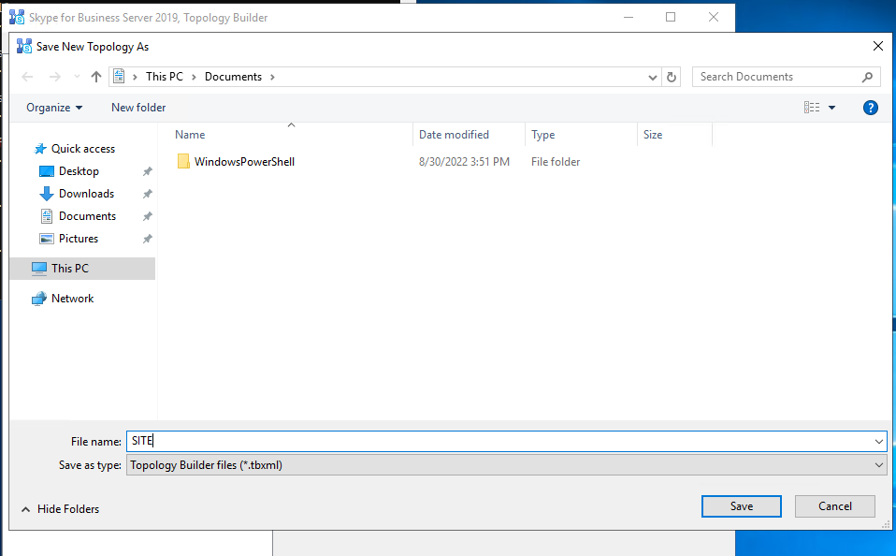

Enter the Primary SIP domain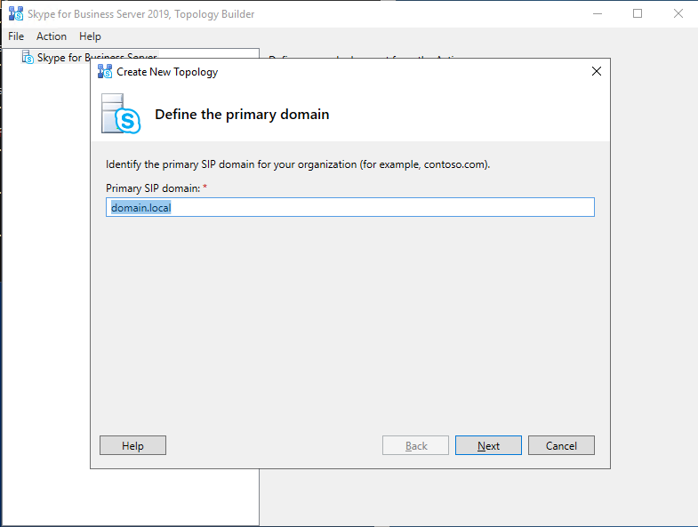

Add any additional SIP Domains, if applicable, other Next

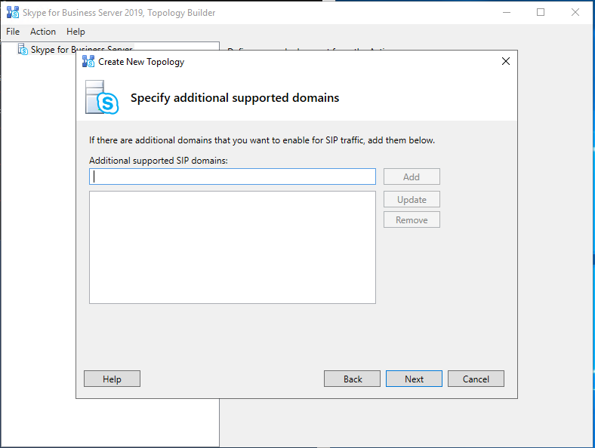

Name the Site

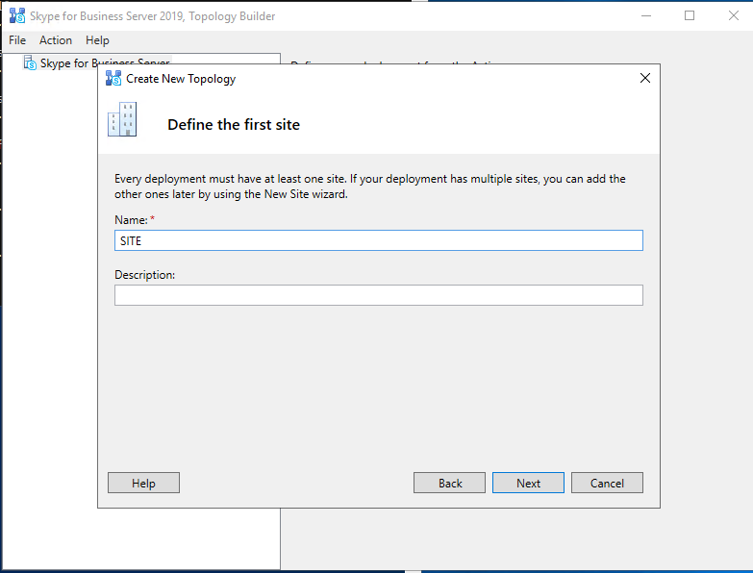

Fill out other information, if required

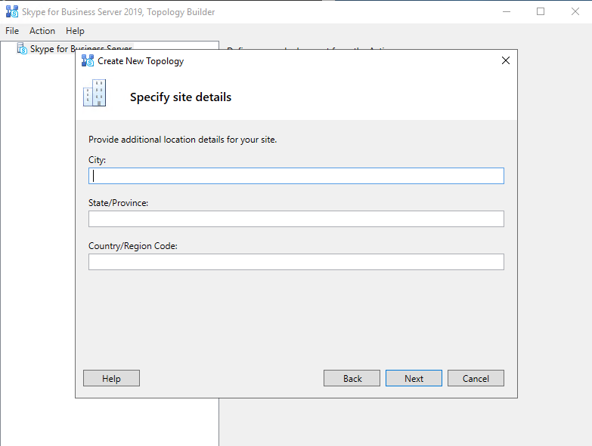

Be sure to leave Open the New Front End Wizard when this wizard closes, Finish

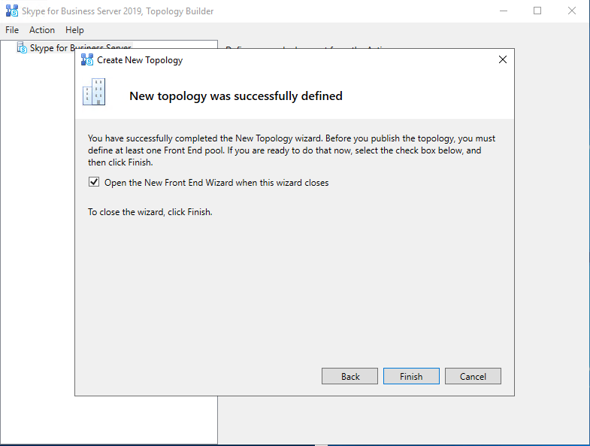

Next

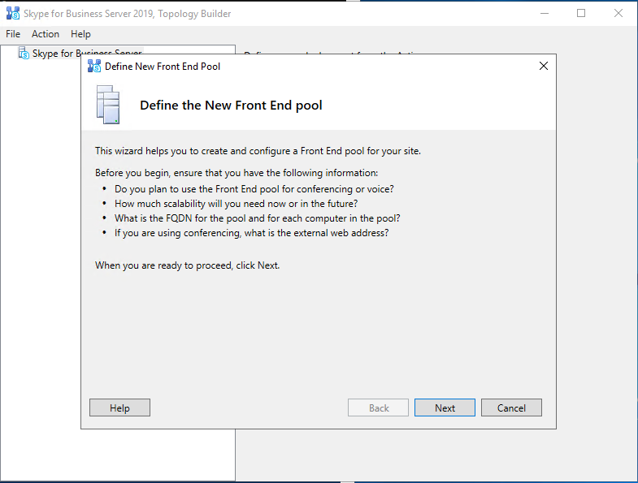

For Standard Server (most installs, change from Enterprise Pool to Standard Edition Server), enter the FQDN of the Server Name in the Pool FQDN and Next

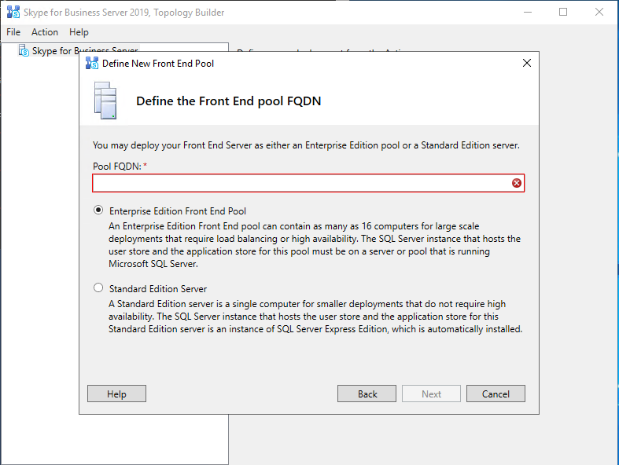

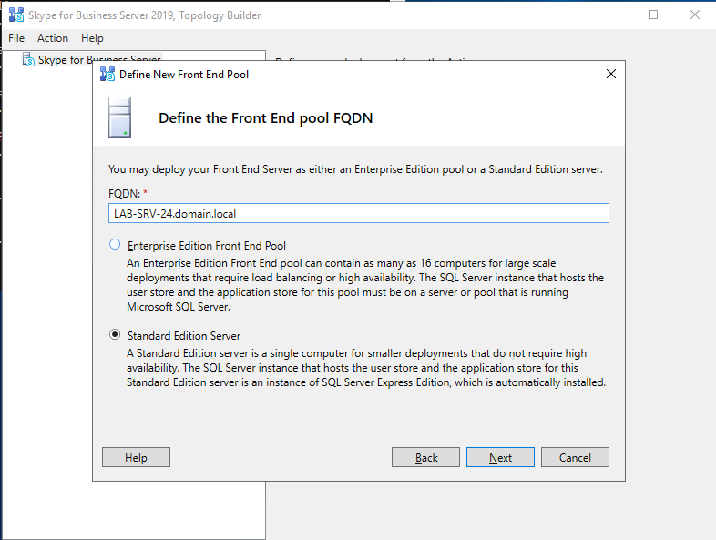

Check box for Conferencing, next

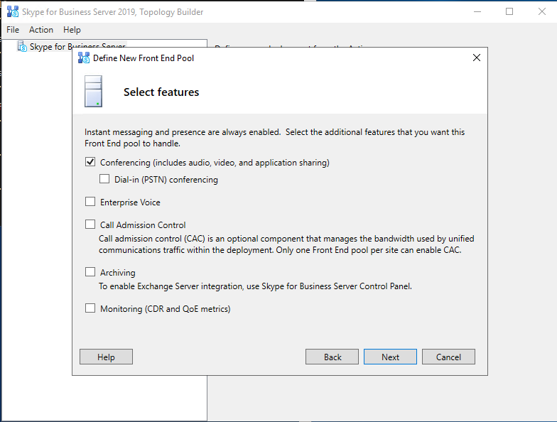

Next

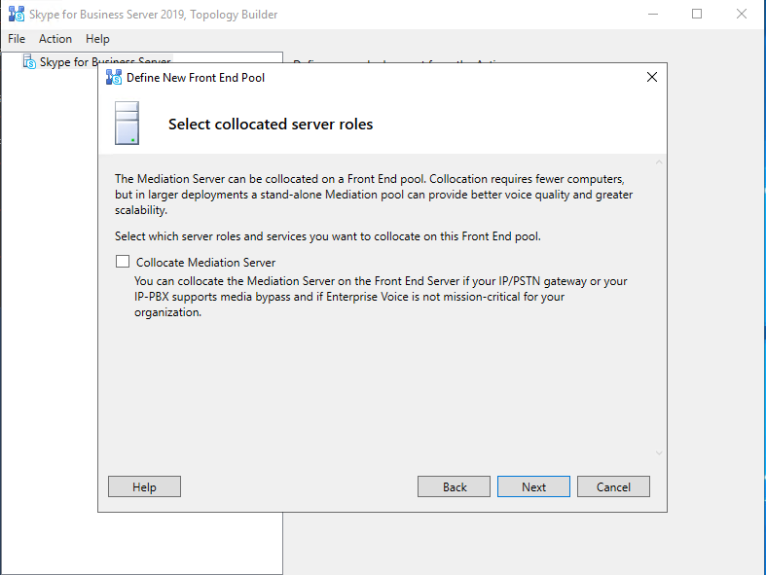

Next

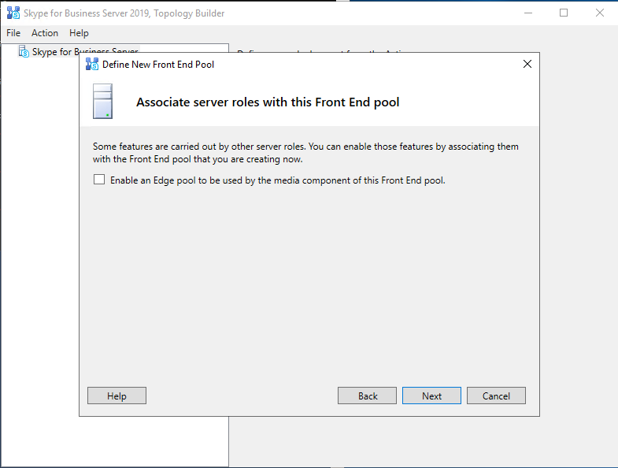

Next

Confirm the SQL Server store, Next

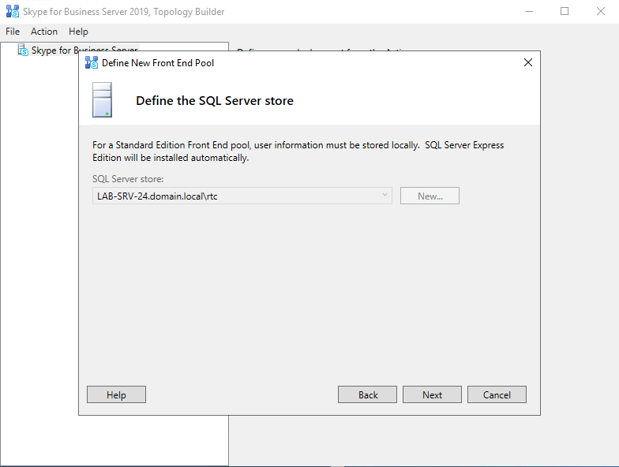

Enter CSShare in the file share location (not this is defined in Config.xml)

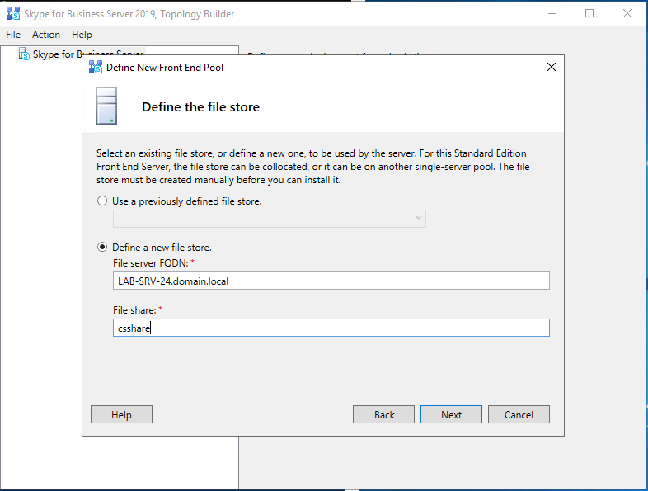

Next

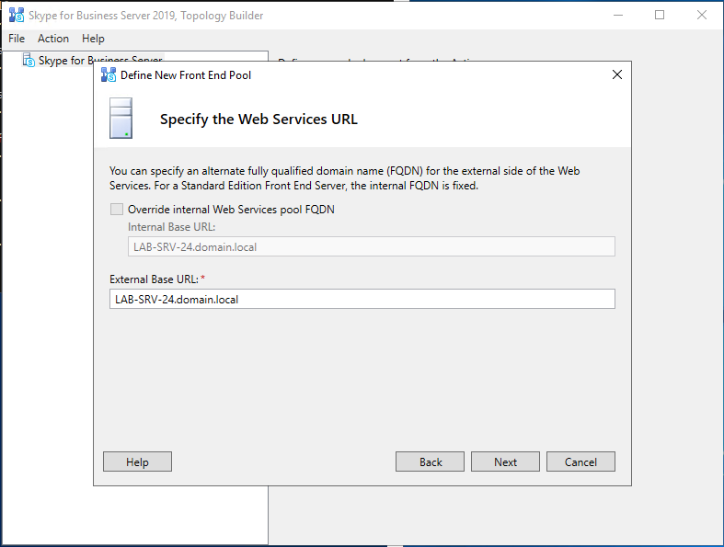

Uncheck Associate pool with an Office Web App Server (in the absence of an Office Web App Server), Finish

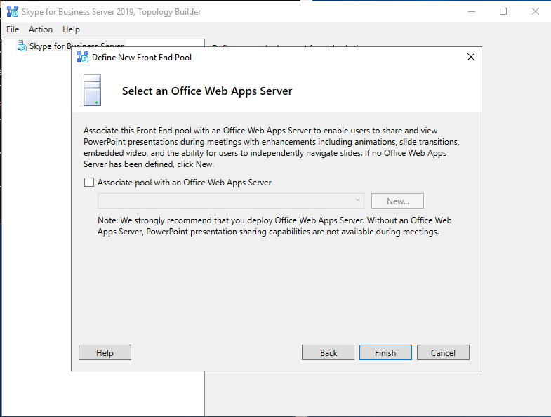

Validate the settings

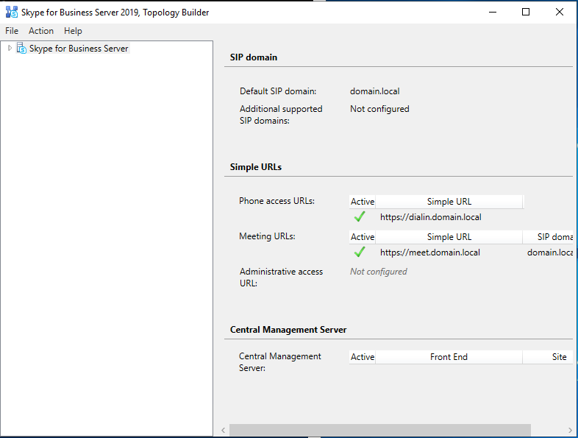

Action – Publish Topology

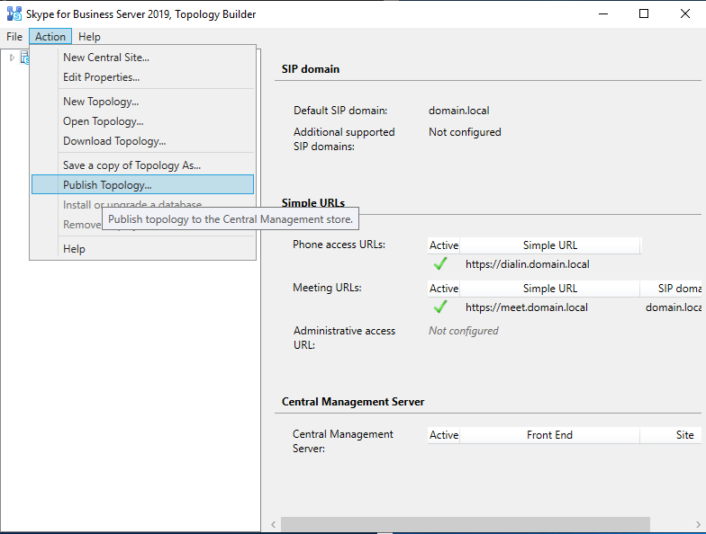

Next

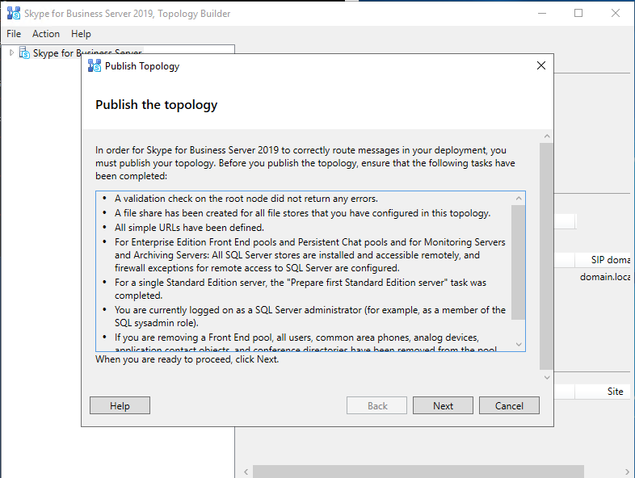

Ensure no errors in Deployment

If an error occurs, you can restart the process again by running command: Remove-CSConfigurationStoreLocation